***HOSPITAL DATABASE MANAGEMENT SYSTEM***

## TO CREATE DATABASE

CTEARE DATABASE Hospital_Management;

* It will create the database with Hospital_Management name.

--------------------------------------------------------------------------------------------------------------------------------------## to USE above database

USE Hospital_Management;

* It will move to Hospital_Management database from MariaDB.

--------------------------------------------------------------------------------------------------------------------------------------

## Now we have to CREATE TABLES structure in database, to store the information

CREATE TABLE Doctor_Details (Dr_id int(11) primary key AUTO_INCREMENT, Dr_Name varchar(35), DOJ date, Department varchar(20), Gender text, Email_ID varchar(30), Contact_No bigint(20), Salary bigint(20));

* It will create table structure with Doctor_Details name, having some columns.

--------------------------------------------------------------------------------------------------------------------------------------

## To check the Structure of create table

DESC Doctor_Details;

* It will display the table structure.

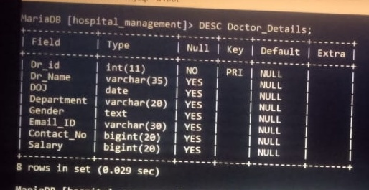

--------------------------------------------------------------------------------------------------------------------------------------## To INSERT the detail information about doctors

INSERT INTO Doctor_Details VALUES (1, "Dr Ashok Mehta", "2021-06-15", "Psychology", "male", "ashok.mailbox@gmail.com", 8965478954, 56000);

INSERT INTO Doctor_Details VALUES(2, "Dr Vitthal Lahane", "2018-02-11", "ENT", "male", "vitthal.mailbox@gmail.com", 9856472124, 80000);

INSERT INTO Doctor_Details VALUES(3, "Dr Chandrakant Gore", "2010-06-11", "ENT", "male", "chandra.mailbox@gmail.com", 9845789234, 60000);

INSERT INTO Doctor_Details VALUES(4, "Dr Kalpana Sindhiya", "2019-06-25", "Orthopedics", "female", "kalpi4U@gmail.com", 9845987234, 70000);

INSERT INTO Doctor_Details VALUES(5, "Dr Dinesh Patil", "2020-08-25", "neurology", "male", "dinesha90@gmail.com", 9730485151, 98000);

INSERT INTO Doctor_Details VALUES(6, "Dr Lakshmi Bhatiya", "2020-12-30", "Gynecology", "Female", "lakshu.mailbox@gmail.com", 8686500346, 23000);

INSERT INTO Doctor_Details VALUES(7, "Dr Sushrusha Surwase", "2020-02-20", "medicine", "Female", "surus.mailbox@gmail.com", 7038407247, 90000);

INSERT INTO Doctor_Details VALUES(8, "Dr Harish Biradar", "2020-08-08", "Medicine", "Male", "sarish2020@gmail.com", 7448028088, 52000);

INSERT INTO Doctor_Details VALUES(9, "Dr Sarika Surwase", "2020-12-12", "ENT", "Female", "sarika003@gmail.com", 8523698574, 67000);

INSERT INTO Doctor_Details VALUES(10, "Dr Prakash Mudhada", "2020-10-22", "Gynecology", "Male", "sangha.1234@gmail.com", 4598687594, 75000);

* It will insert the all the 10 records with the given above information.

-------------------------------------------------------------------------------------------------------------------------------------

## To fetch the information or details from above table

SELECT * FROM Doctor_Details;

* It will display the complete table having all detail information.

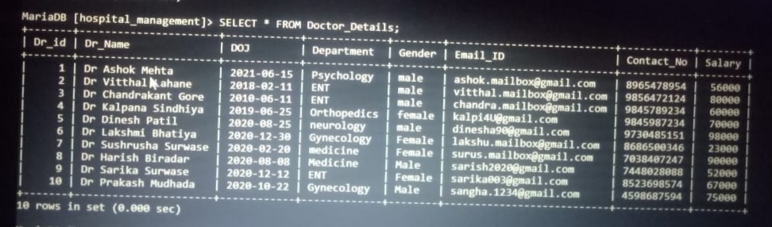

==================================================================================

## Now we have to CREATE one more TABLES structure in database, to store the information

CREATE TABLE Patient_Details (P_id int(11) primary key AUTO_INCREMENT, P_Name varchar(40), aadhar_no bigint(20) UNIQUE, Gender text, room_no int(11), DOA date, Dr_id int(11) references Doctor_details (Dr_id), S_id int(11), diseases varchar(25), Contact bigint(20), Address text, Blood_group varchar(5), Discharge_Date date);

* It will create table structure with Patient_Details name, having some columns.

--------------------------------------------------------------------------------------------------------------------------------------## to check the Structure of create table

DESC Patient_Details;

* It will display the table structure.

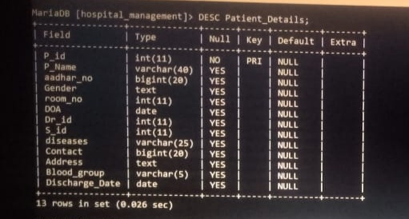

--------------------------------------------------------------------------------------------------------------------------------------

## To INSERT the detail information/Records

INSERT INTO Patient_Details VALUES (1, "Smith", 897789875634, "Male", 1, "2022-08-15", 7, 4, "Cough and cold", 8456786543, "Mumbai", "O+ve", "2022-08-21");

INSERT INTO Patient_Details VALUES (2, "Wilson", 674523908765, "Male", 2, "2001-03-01", 4, 5, "Joint Pain", 9823033215, "Pune", "A+", "2001-06-05");

INSERT INTO Patient_Details VALUES (3, "King", 897654346798, "Male", 3, "2001-06-01", 3, 4, "Knee Pain", 9623009816, "Nagpur", "B+", "2002-06-05");

INSERT INTO Patient_Details VALUES (4, "Elisa", 996787907756, "Female", 1, "2006-01-23", 2, 3, "Throat Infection", 7765437898, "Nashik", "AB+", "2008-01-15");

INSERT INTO Patient_Details VALUES (5, "Leeza", 786866846722, "Female", 3, "1990-01-23", 1, 5, "Mental Disorder", 9945678723, "Thane", "O+", "1998-01-15");

INSERT INTO Patient_Details VALUES (6, "Rakesh", 558977990997, "Male", 2, "2014-09-18", 1, 4, "Anxiety", 8888679067, "Pune", "A-", "2016-05-21");

INSERT INTO Patient_Details VALUES (7, "Narendra", 784509341290, "Male", 1, "2020-09-18", 8, 3, "Chemical Infection", 8888406545, "Dadar", "B-", "2020-09-21");

INSERT INTO Patient_Details VALUES (8, "Liza", 844384459886, "Female", 3, "2021-08-18", 3, 5, "cough", 8482983699, "mumbai", "A+", "2021-08-21");

INSERT INTO Patient_Details VALUES (9, "Liza", 844384459896, "Female", 3, "2003-08-20", 3, 5, "cough", 8482983699, "mumbai", "A+", "2002-03-20");

* It will insert the all the records with the given above information.

--------------------------------------------------------------------------------------------------------------------------------------## To fetch the information or details from above table

SELECT * FROM Patient_Details;

* It will display the complete table having all detail information.

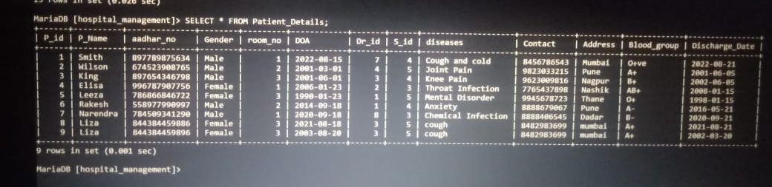

-------------------------------------------------------------------------------------------------------------------------------------

==================================================================================

## Now we have to CREATE one more TABLES structure in database, to store the information

CREATE TABLE Room (Room_no int(11) primary key, Room_Type varchar(20), P_id int(11) references Patient_details (P_id));

* It will create table structure with Patient_Details name, having some columns.

--------------------------------------------------------------------------------------------------------------------------------------

## To check the Structure of create table

DESC Room;

* It will display the table structure.

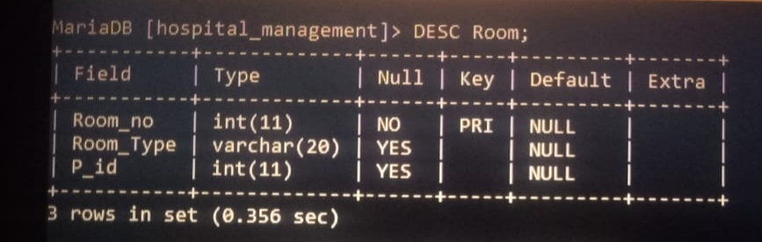

--------------------------------------------------------------------------------------------------------------------------------------

## To INSERT the detail information/Records

INSERT INTO Room VALUES (1, "General", 4);

INSERT INTO Room VALUES (2, "VIP", 2);

INSERT INTO Room VALUES (3, "ICU", 6);

* It will insert the all the records with the given above information..

-------------------------------------------------------------------------------------------------------------------------------------

##to fetch the information or details from above table

SELECT * FROM Room;

* It will display the complete table having all detail information.

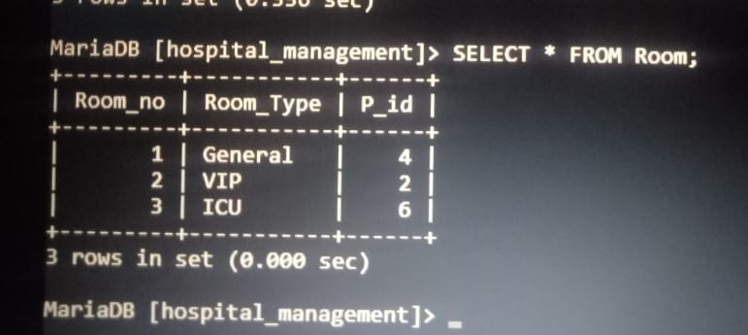

--------------------------------------------------------------------------------------------------------------------------------------

==================================================================================

## Now we have to CREATE one more TABLES structure in database, to store the information

CREATE TABLE Bill_Details (Bill_no int(11) primary key AUTO_INCREMENT, P_id int(11) references Patient_id (P_id), Dr_charge bigint(20), Medicine_charge bigint(20), Room_charge bigint(20), Operation_charge bigint(20), Lab_charge bigint(20), Total_Bill bigint(20) NOT NULL, Paid_Bill bigint(20) NOT NULL);

* It will create table structure with Patient_Details name, having some columns.

--------------------------------------------------------------------------------------------------------------------------------------

## To check the Structure of create table

DESC Bill_Details;

* It will display the table structure.

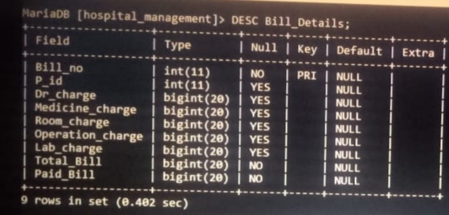

--------------------------------------------------------------------------------------------------------------------------------------

## To INSERT the detail information/Records

INSERT INTO Bill_Details VALUES (101, 1, 300, 1000, 500, 2000, 500, 4300, 4300);

INSERT INTO Bill_Details VALUES (102, 2, 300, 1500, 500, 5000, 700, 8000, 8000);

INSERT INTO Bill_Details VALUES (103, 3, 300, 800, 500, 00, 400, 2000, 2000);

INSERT INTO Bill_Details VALUES (104, 4, 300, 1500, 500, 5000, 1500, 8800, 8000);

INSERT INTO Bill_Details VALUES (105, 5, 300, 1000, 1000, 2000, 1000, 5300, 5300);

* It will insert the all the records with the given above information.

--------------------------------------------------------------------------------------------------------------------------------------## To fetch the information or details from above table

SELECT * FROM Bill_Details;

* It will display the complete table having all detail information.

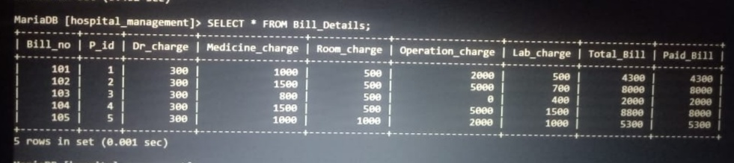

--------------------------------------------------------------------------------------------------------------------------------------==================================================================================

## Now we have to CREATE one more TABLES structure in database, to store the information

CREATE TABLE Discharge (Serial_no int(11) primary key, Bill_no int(11) references Bill_Details (Bill_no), Discharge_Date date NOT NULL, Room_no int(11), Paid_Bill bigint(20) NOT NULL);

* It will create table structure with Patient_Details name, having some columns.

--------------------------------------------------------------------------------------------------------------------------------------

## To check the Structure of create table

DESC Discharge;

* It will display the table structure.

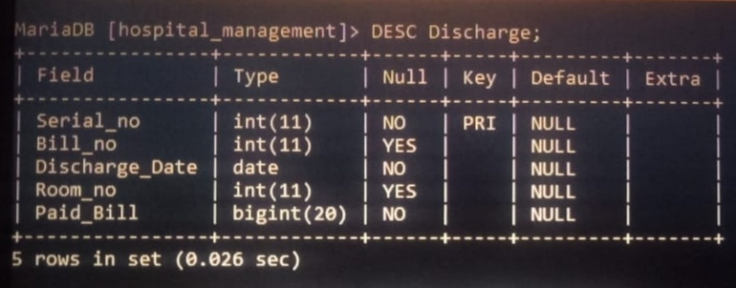

--------------------------------------------------------------------------------------------------------------------------------------

## To INSERT the detail information/Records

INSERT INTO Discharge VALUES (501, 101, "2002-06-05", 3, 4300);

INSERT INTO Discharge VALUES (502, 102, "2022-08-21", 1, 8000);

INSERT INTO Discharge VALUES (503, 103, "1998-01-15", 3, 2000);

INSERT INTO Discharge VALUES (504, 104, "2001-06-05", 2, 8800);

INSERT INTO Discharge VALUES (505, 105, "2008-01-15", 1, 5300);

* It will insert the all the records with the given above information.

--------------------------------------------------------------------------------------------------------------------------------------## To fetch the information or details from above table

SELECT * FROM Discharge;

* It will display the complete table having all detail information.



